Cover Page

Grantee Name: Driscoll Children’s Health Plan

State: Texas

Grantee Project Title: Telehealth Network Grant Program
aka “Healthy Families”

Grant Number: H2AIT16625-02-02

Principal Investigator: Dr. Mary Dale Peterson

Telephone: (361) 694-4889

Date: October 03, 2011

Table of Contents
Summary 3
Areas of Focus for Messaging Changes 4
Original Message Flows 6
Original Tier 1 and Tier 2 Messaging Flows 6
Original Asthma Messaging Flows 7
Message Flow Modifications 9
Message Flow Modification Illustrations 10
General Messaging and Diabetes Message Flow Modifications 10
Asthma Message Flow Modifications 11
Question Session Concept Message Flow 12
Combined View of Message Flow Modifications 13
Question Database Changes 14
Question Database Table 14
Analysis 18
Quarterly Report Data Analysis 18
Opt Out Rate Analysis 21

Illustration Index
Illustration 1: Original Message Flow for Tier 1 and Tier 2 (General/Diabetes) 6
Illustration 2: Original Asthma Messaging Flow 7
Illustration 3: Original Asthma Messaging Flow - Active Messaging Detail 8
Illustration 4: Modifications to Diabetes Messaging flow 10
Illustration 5: Modifications to Asthma Messaging Flow 11
Illustration 6: Question Session 12
Illustration 7: Modifications to Diabetes and Asthma Message Flow (Combined) 13
Illustration 8: Messaging Metrics Graph 19
Illustration 9: Messaging Metrics Table 19
Illustration 10: HEDIS Metrics Table 20
Illustration 11: HEDIS Metrics Graph 20

Summary
Originally, the OAT text messaging algorithms that collect information from participants were designed to be very 'low touch', with infrequent and indirect messaging to the participants. The messaging algorithms also operated in a strict sequence and didn't offer an ability to readily try different approaches to asking questions. Using this approach, response rates to some questions, such as Zip Code and Healthy Families Goal, were acceptable. However, over time, it became apparent that other response rates, for questions such as what specific chronic conditions are in a particular household, Performance Improvement Measurement System (PIMS) metrics and Healthcare Effectiveness Data and Information Set (HEDIS) metrics, were below expectations.
In an attempt to increase the text messaging response rates a range of changes to the text messaging system were implemented. These text messaging changes focused on the questions themselves, as well as the algorithms and methods used to ask the questions. Details of these changes are included in this document in the following sections:
- Areas of Focus for Messaging Changes,
- Messaging Flow Modifications and
- Question Database Changes.
Analysis shows the text messaging modifications resulted in an much 'higher touch' program that effectively collected self reported data from the general population. The quality of the metrics that were collected also improved, with the random questions creating a more even response distribution across all question types.
The increase in message frequency as well as data requests did increase the opt out rate to 30%, however the remaining 70% of the population actively participated in the text messaging program, including providing responses to the more frequent questions.

Areas of Focus for Messaging Changes
Modifications were made to the text messaging system in two broad areas:
- Messaging Question Database – the text message questions themselves were updated
- Messaging Algorithms – things such as mixture of questions to education, frequency of education, frequency of questions, number of questions asked in a session, etc.
Focus | Description
Ask more specific questions | Activity: Each question in the message database was reviewed, and the message database was updated with more specific questions.  Detail: Compare asking more specific questions vs asking more general questions.  e.g. direct "Do you have diabetes?" general "What is your area of health interest?"  The broad enrollment approach we started with used general questions.  Measure the response rate of more specific questions and compare to the previous response rate.
Ask all questions | Activity: Update code in messaging system to use Question Pool concept.  Detail: Ask additional questions even if there was not a response to one of the previous questions.  The current algorithm simply repeats the previous question until it's answered, so users may get stuck if they do not want to answer a particular question.
Word questions differently | Activity: Each question in the message database was reviewed, and the message database was updated with re-worded questions.  Detail: Adjust the wording of questions dynamically to determine the wording that gets the highest response rate.  Setup one of the questions to go to participants, and measure that groups response rate. Change the wording of the question, and compare the response rate to the first group. Use the version of the question that with the highest response rate.
Question sequence | Activity: Update code in messaging system to use Question Pool concept. Added question sequence to the question database so the order questions are asked can me modified dynamically.  Detail: Ask the questions in a different order and compare the response rates.  Use the question sequence that yields the highest response rate
Education and question 'mix' | Activity: Update code in messaging system to allow control of the frequency messages are sent, and the frequency questions are asked, combining these two configurable parameters to change the mix of questions and education.  Detail: Change the mix of tips and questions. e.g. 3 tips, then a question, or one tip, then one question?  Compare the response rate and use the method with the highest response rate.
Best time of day and day of week to ask | Activity: Update code in messaging system to allow control of the time of day and day of week messages are sent. Adjust these parameters to find the most effective time of day and day of week.  Detail: Measure the response rate by time of day and day of week.  Target questions to the times of day and days of week that have the highest response rates. Compare response rates before and after the change.
Message frequency | Activity: Update code in messaging system to allow control of the frequency messages are sent, and the frequency questions are asked, combining these two configurable parameters to change the mix of questions and education.  Detail: Message participants more frequently and see if they answer more questions when they are messaged more than once a week
Multiple choice answers | Activity: Each question in the message database was reviewed, and the message database was updated with multiple choice answers where appropriate. The message system was updated to handle the multiple choice responses.  Detail: Provide multiple choice responses instead of asking for open ended or free form answers,  for example "Reply Y if you have diabetes" vs "Reply with your area of interest" or "Reply Y if your goal is to lose weight" vs "What is your goal?"
Request full profile in a single session | Activity: Implement the Question Session concept in the messaging algorithms.  Detail: Ask people if they would like to fill out their entire profile in one session. Instead of asking over time as is done now, ask the profile questions immediately in sequence and see if participants respond to more questions than if they are asked over time. In practice there are almost 20 questions to fully fill out a profile for someone with diabetes and asthma in the household. So modified to ask three questions in a given 'session'. Question Session – when a response to a question is received, another question is asked immediately (up to three questions per session)

Original Message Flows

Original Tier 1 and Tier 2 Messaging Flows
- The original question flow featured 'low touch' infrequent messaging
- Questions were asked in strict sequence

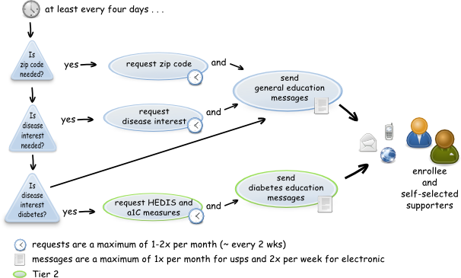Illustration 1: Original Message Flow for Tier 1 and Tier 2 (General/Diabetes)

Original Asthma Messaging Flows
- Includes profile setup, data requests for controller medication compliance, data request for asthma 'zone' (green/red/yellow)
- Includes survey at completion of 120 day asthma program

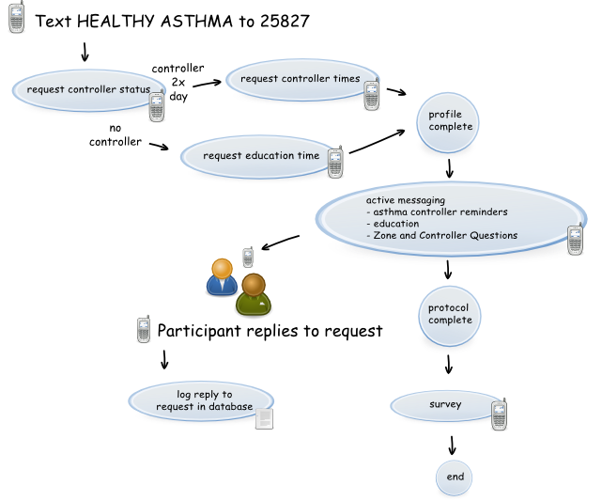Illustration 2: Original Asthma Messaging Flow
- Active messaging for asthma (illustration below) has a message frequency of one or two messages per day, depending on profile setup.
- The first message of the day is focused on one of seven areas: Controller compliance, Asthma Zone, Encouragement, Symptoms, Environment, Triggers, General Health.
- Each week one controller compliance question is asked, and one zone question is asked.
- Messages are randomly selected from the categories that have not been seen yet for the week
- All replies are logged to the database

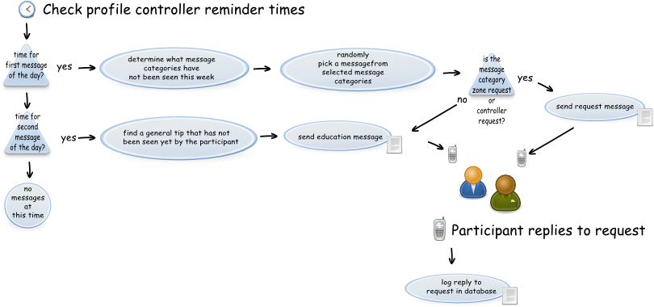Illustration 3: Original Asthma Messaging Flow - Active Messaging Detail

Message Flow Modifications
- Message flow modifications place an emphasis on collecting data for Performance Improvement Measurement System (PIMS) metrics and Healthcare Effectiveness Data and Information Set (HEDIS) metrics.
- The updated messaging algorithms feature a 'high touch' approach, with
  - more frequent education messages
  - more frequent questions
- The messaging algorithms were updated with new concepts that attempt to increase responses to PIMS and HEDIS questions:
  - Question Session concept – when a response to a question is received, another question is asked immediately (up to three questions per session)
  - Question Pool concept – find all questions that are relevant for someone, based on their previous responses. For example, if the person has indicated there is diabetes in the household, they are eligible for HEDIS questions. If they have indicated diabetes or asthma is in the household, they are eligible for HEDIS and PIMS questions. Any of these questions that do not have answers are put into the pool of questions they may be asked.
  - Least Asked Question concept – for a question the pool of unanswered questions, ask the question that was asked the longest time ago. This ensures all questions are asked and that a person gets multiple opportunities to answer any unanswered questions, without repeating the same question over and over.
- The Question Session concept, Question Pool concept and Least Asked Question concept were put into the general messaging, diabetes messaging and asthma messaging flows.

Message Flow Modification Illustrations

General Messaging and Diabetes Message Flow Modifications
- Messaging frequency was increased to every two days
- The Question Pool concept was added to the flow
- The Least Asked Question concept was added to the flow
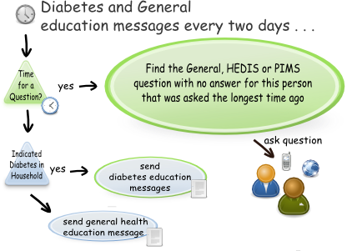Illustration 4: Modifications to Diabetes Messaging flow

Asthma Message Flow Modifications
- Asthma message frequency is one or two messages per day, depending on profile
- General (Age/Zip Code) and PIMS Questions were added to the asthma flow. Two times per week a message with a PIMS, Zone or Controller Compliance question is asked. 75% of the time the system asks a PIMS question, with the remaining 25% of the questions being Zone or Controller Compliance
- The Question Pool concept was added to the flow
- The Least Asked Question concept was added to the flow
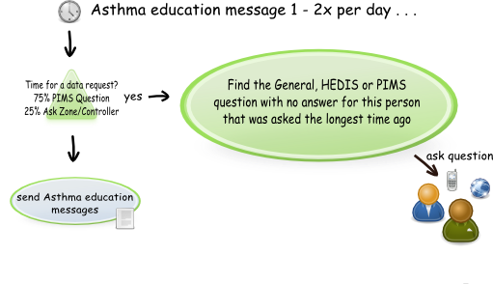Illustration 5: Modifications to Asthma Messaging Flow

Question Session Concept Message Flow
- For both the diabetes and asthma flows, the Question Session concept was implemented.
- When a response to a question is received, another question is asked immediately (up to three questions per session).
- The Question Pool and Least Asked Question concept are used for all questions in the Question Session
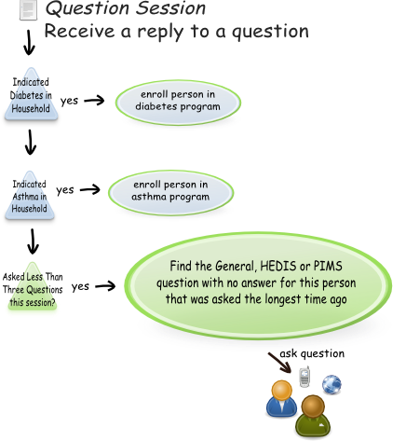Illustration 6: Question Session

Combined View of Message Flow Modifications
- The messaging modifications for the general messaging, diabetes and asthma flows were integrated into a complete message flow, as shown below

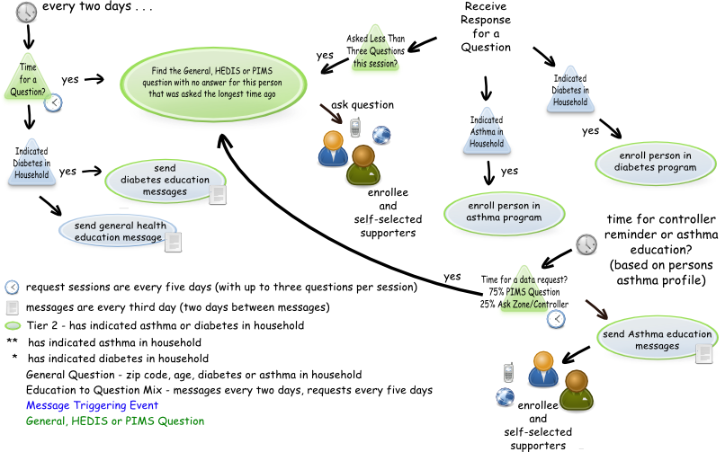Illustration 7: Modifications to Diabetes and Asthma Message Flow (Combined)

Question Database Changes
- The message database has over 650 messages
  - 20 questions
  - 206 asthma messages
  - 180 diabetes messages
  - 247 general health messages
- Questions were given a category for placing them into the Question Pool . Categories are: 'general', 'diabetes' and 'asthma'.
- Question wording was updated per the recommendations and updated in the question database.
- Unneeded questions were removed.
- Emphasis was put on asking PIMS/HEDIS questions.

Question Database Table
The table below high lights the changes made to the questions in the message database.
Original Question | Updated Question | HEDIS / PIMS / Notes
Reply with your zip code for a local version of Healthy Families! | Reply with your zip code for a local version of Healthy Families! | PIMS  Needed for area served
Reply with your Healthy Families goal for this year. Commit to your goal now! hfstx.org' | Removed | Removed (not HEDIS or PIMS)
Reply with your activity! Research shows that 3 ten minute walks are just as good for you as 1 thirty minute walk. | Removed | Removed (not HEDIS or PIMS)
Reply with any health conditions you are interested in to customize Healthy Families with specific tips! | Do you or someone in your home have diabetes or asthma? Reply with the letter D for Diabetes,A for Asthma,B both,N for neither. | PIMS
– | Please reply with the letter for your age range: A:under-18 B:18-21 C:22-34 D:35-44 E:45-54 F:55-64 G:65-and-up | PIMS
– | What was the last year you went to the Emergency Department for asthma? Reply 2011 (for example) or NEVER. | PIMS ED Visits
– | What was the last year you stayed in the hospital asthma? Reply 2011 (for example) or NEVER. | PIMS Hospitalizations
– | What was the last year you saw your regular asthma doctor (not hospital or emergency)? Reply 2011 (for example) or NEVER. | PIMS (Currently under care of physician for asthma)
– | What was the last year you went to the Emergency Department for diabetes? Reply 2011 (for example) or NEVER. | PIMS ED Visits
– | What was the last year you stayed in the hospital diabetes? Reply 2011 (for example) or NEVER. | PIMS Hospitalizations
– | What was the last year you saw your diabetes doctor (not hospital or emergency)? Reply 2011 (for example) or NEVER. | PIMS (Currently under care of physician for diabetes)
Reply with the number of A1c tests you've had in the last 12 months. | How many A1c tests have you had in the last 12 months? Reply with the number (1 for example), or NONE | HEDIS
Reply with your most recent A1c laboratory test result (or never had one). | What was your last A1c test result? Reply with the A1c number or NEVER HAD ONE. | HEDIS
Reply with the last year you were seen by a doctor about the health of your kidneys (or never). | What was the last year you saw a doctor about your kidneys? Reply 2011 (for example) or NEVER. | HEDIS
Reply with the last year you had a lipid profile (or never) | What was the last year you had a lipid profile done? Reply 2011 (for example) or NEVER. | HEDIS
Reply with your ldl cholesterol level (the bad kind). | What was your last cholesterol test result? Reply with the number or HIGH or NORMAL, or NONE if you do not know | HEDIS
Reply with your last blood pressure reading (140/90 for example, or none). | What was your last blood pressure reading? Reply with 140 over 90 (for example) HIGH or NORMAL or NONE if you do not know. | HEDIS
Reply with your last blood pressure reading (140/90 for example, or none). | What was the last year you had a dilated eye exam? Reply 2011 (for example) or NEVER. | HEDIS
Reply with the last year you had a foot exam (or never). | What was the last year you had a diabetes foot exam? Reply 2011 (for example) or NEVER. | HEDIS
Reply yes if you smoke and have received counseling about stopping smoking. | Have you gotten counseling to help stop smoking? Reply yes or no. | HEDIS
How are you feeling... what zone are you in? Reply with green, yellow or red. | How are you feeling... what zone are you in? Reply with green, yellow or red. | For Reporting Metrics
Everyone forgets their controller sometimes. How many times did you miss this week? Reply with the number you missed.r | Everyone forgets their controller sometimes. How many times did you miss this week? Reply with the number you missed. | For Reporting Metrics
Asthma Survey | While you were in the asthma program, how many school days were missed for asthma? | For Reporting Metrics
Asthma Survey | While you were in the asthma program, how many times did you go to the emergency room for asthma? | For Reporting Metrics
Asthma Survey | While you were in the asthma program, how many days did you have asthma symptoms? | For Reporting Metrics

Analysis

Quarterly Report Data Analysis
Each set of metrics in the quarterly reports are also collected on a monthly basis, allowing us to observe the impact of the messaging changes on each of the metrics previous months history.

Each set of metrics related to text messaging is below, with associated observations, as well as opt out rate analysis.

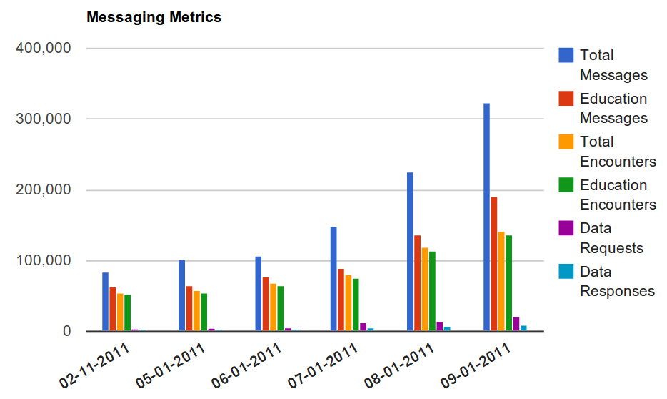
Messaging Metrics
Illustration 8: Messaging Metrics Graph

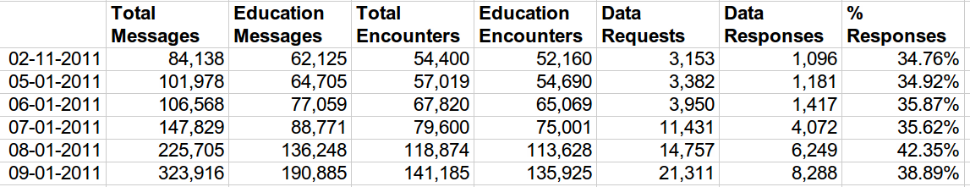
Illustration 9: Messaging Metrics Table

The messaging changes resulted in many more encounters overall, due to the increased outbound education message frequency. Message volume through August was 3x the volume reported in June, at 323,916 total messages.
The number of data requests also showed and increase due to the new algorithms, with a total of 21,311 data requests. An interesting outcome was that the data responses saw an improved response rate, going from 35% to a high of 42%. This, along with the higher frequency of requests, resulted in a much larger total number of 8,288 data responses.
HEDIS Metrics
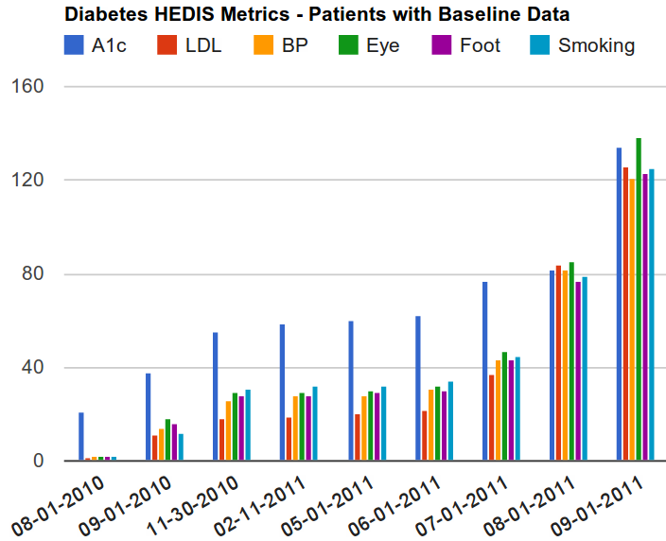
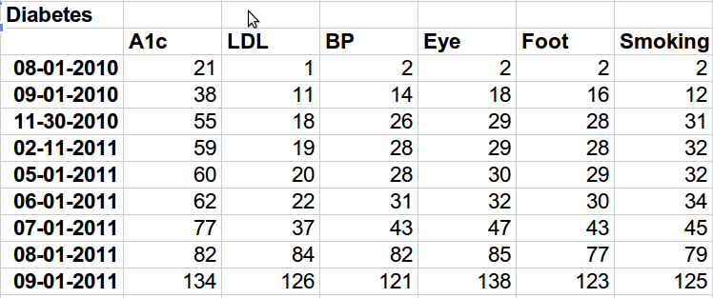
Illustration 11: HEDIS Metrics Graph
Illustration 10: HEDIS Metrics Table

The HEDIS metrics data collection effort saw improvements in the total number of metrics collected, as well as the distribution of data collected.
Initially, there was a significant drop off in the number of metrics collected after the first A1c metric was asked. After the messaging algorithm changes, the response rate evened out across the metrics, with higher numbers in every category.
Our hypothesis is that asking the questions randomly and asking them in a 'Question Session' with a few questions in a row (when someone continued to respond), led to the improvements in the HEDIS data collection.

Opt Out Rate Analysis
We anticipated that changing the messaging frequency and algorithms would result in a higher opt out rate than we saw previously. In the early phases of the program, the opt out rate was miniscule, with fewer than ten people opting out of the entire program. Our hypothesis is that the 'low touch' messaging kept people from opting out. Once the messaging algorithms were changed to the 'high touch' model, the opt out rate did increase.
We had a peak of 9805 cell phones identified in the database, with 8300 total cell phones still eligible to receive messages at the end of August. Some of these 8300 had received an invite to the asthma program, for example, and had not opted out even though they didn't enroll in the asthma program, so they are still eligible to receive invitations to future text message based programs.
We saw a total of 1506 opt outs by the end of August, with 3442 active cell numbers receiving messages. So with approximately 5000 active cell phones receiving messages, we saw a final opt out rate of about 30%. While this is high, it is also true that the 3442 remaining active cell phones were continued in the program with the more 'high touch' messaging, and responded to a large number of data requests, making for an effective method of collecting user reported data from the general population.

